University of Missouri HR Form Instructions for VSAS
This form contains the drug screen and background checks you will need to complete to be vetted by the University of Missouri should you be offered a spot. We must receive this form signed off by an official of your home school. All required documents must be uploaded to VSAS, not emailed to coordinators. The University of Missouri does not need to receive the actual reports from the background check or drug screen. You will only need to complete the Nationwide Criminal Background Check. Below are instructions on how to run each check, you will need to write the date it was passed in the form (example below):
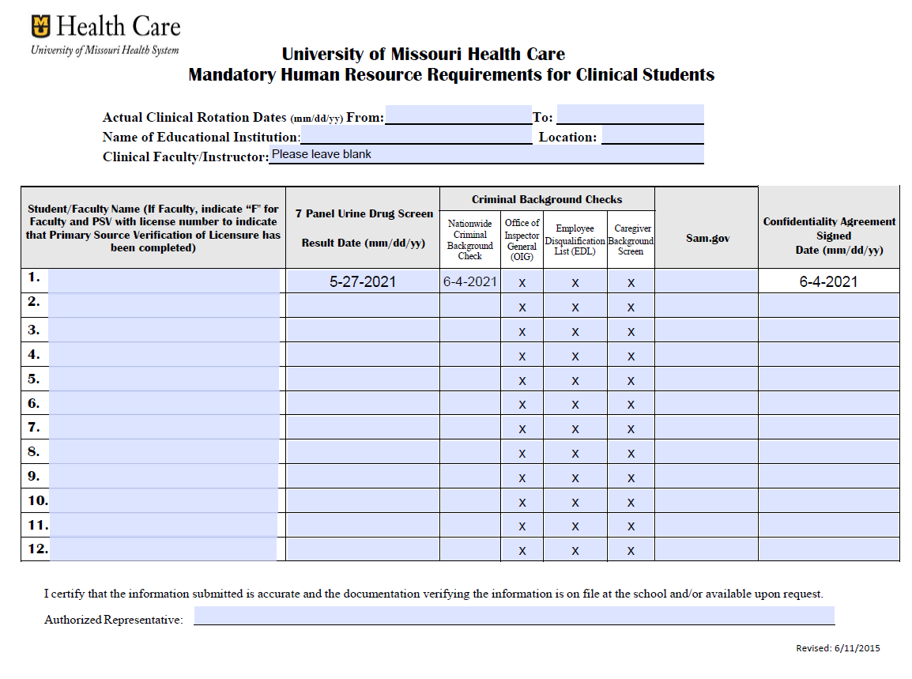
Drug Screen
- Needs to be within the last 12 months of this application.
Background Check
- National Criminal Background Check must be completed, this can be the one completed upon matriculation into Medical School cannot be more than 3 years old.
Confidentiality Agreement
- Please add the date you signed the Access and Confidentiality Agreement (you had to upload the document as part of your VSLO application).

