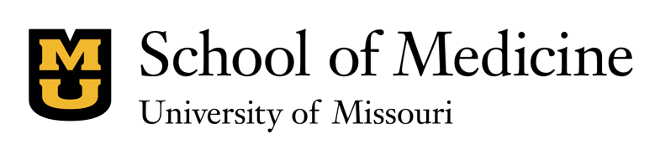

Story Contact: Eric Maze, mazee@health.missouri.edu, 573-882-3656

MU School of Medicine Researcher Receives $4 Million in Federal Grants to Study Two Debilitating Eye Conditions

The grants will fund corneal scarring and diabetic retinopathy research

COLUMBIA, Mo. (Dec 17, 2019) ― The National Institutes of Health has awarded Rajiv Mohan, PhD, professor of ophthalmology at the University of Missouri School of Medicine, two separate grants totaling $4 million to study possible treatments for corneal scarring and diabetic retinopathy, two conditions that hinder vision for nearly 95 million Americans.

One of the NIH grants will fund Mohan’s ongoing gene-based research program directed toward finding treatments for corneal scars, a common cause of blindness resulting from an injury, infection or trauma to the eye. Abnormal scarring after trauma creates haze in the cornea that disrupts vision. The current treatment for this scarring is corneal transplant surgery. However, Mohan plans to study non-surgical topical treatment options that could reverse the haze and restore clear vision.

“The annual economic burden of all fibrotic disorders including the cornea in America alone is about $400 billion,” Mohan said. “I am very excited this new NIH grant allows me to study whether reversal of corneal fibrosis is possible. This is especially important because the scarring process in the cornea is similar to the development of fibrosis in other eye and non-eye tissues. So, if we can find a way to reverse the fibrotic process in the cornea, we can potentially apply the knowledge to discover new treatments for fibrosis in other organs.”

In the other grant, Mohan will work with principal investigator Shyam Chaurasia, PhD, assistant professor at the University of Missouri College of Veterinary Medicine, on a treatment for diabetic retinopathy. Diabetic retinopathy is a common diabetes complication that occurs when abnormal blood vessels form at the back of the eye and cause blurred vision, floaters or vision loss. This project will focus on studying how inhibiting a particular protein may slow or stop the progression of the disease.

The NIH grant to study corneal fibrosis is a four-year, $1.6 million award that runs through August 2023, while the research into diabetic retinopathy is a five-year award that totals $2.4 million and runs through 2024. In addition to these two grants. Mohan has three other NIH grants and one Merit grant from the United States Department of Veteran Health Affairs.

###

About the MU School of Medicine
The MU School of Medicine has improved health, education and research in Missouri and beyond for more than 170 years. MU physicians treat patients from every county in the state, and more Missouri physicians received their medical degrees from MU than from any other university. For more information, visit http://medicine.missouri.edu/.
For more news, visit:
http://medicine.missouri.edu/news/

MU Health Public Relations, One Hospital Drive, Columbia, MO 65212
Twitter @muhealth · Facebook.com/MUHealthCare · Instagram.com/MUHealth · Pinterest.com/MUHealth

